# Experiment-1.1

**Student Name:** Rahul **UID:** 21MCA3152

**Branch:** MCA **Section/Group:**21MCA-9B

**Semester:** 3rd **Date of Performance:** 31/08/22

**Subject Name:** ML Lab **Subject Code:** 21CAP-703

# **Task to be done:**

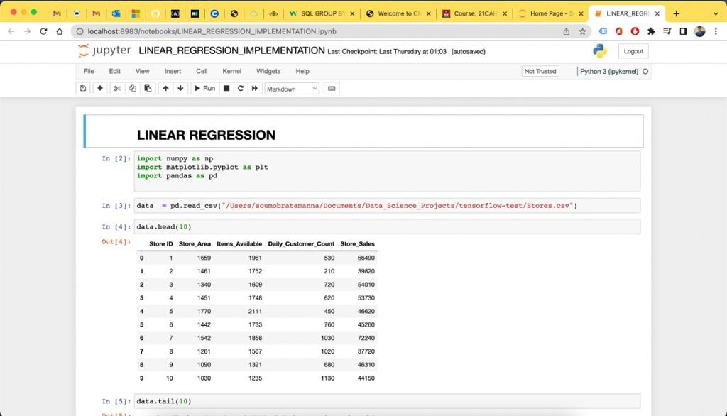

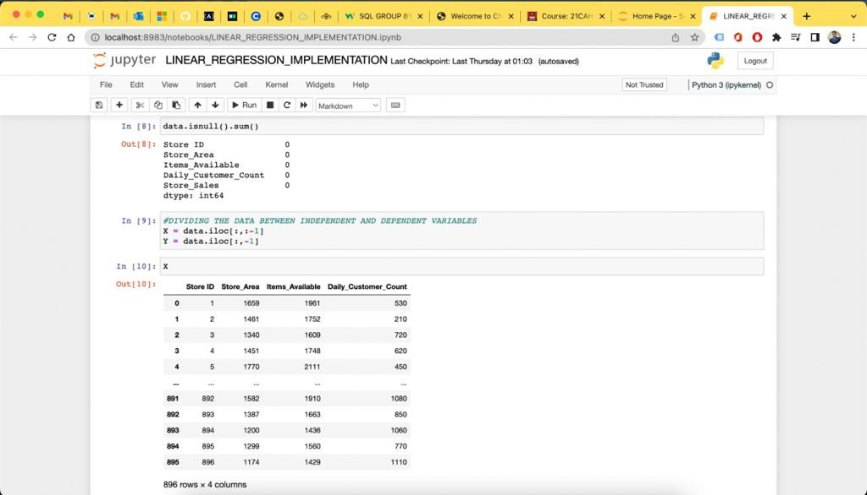

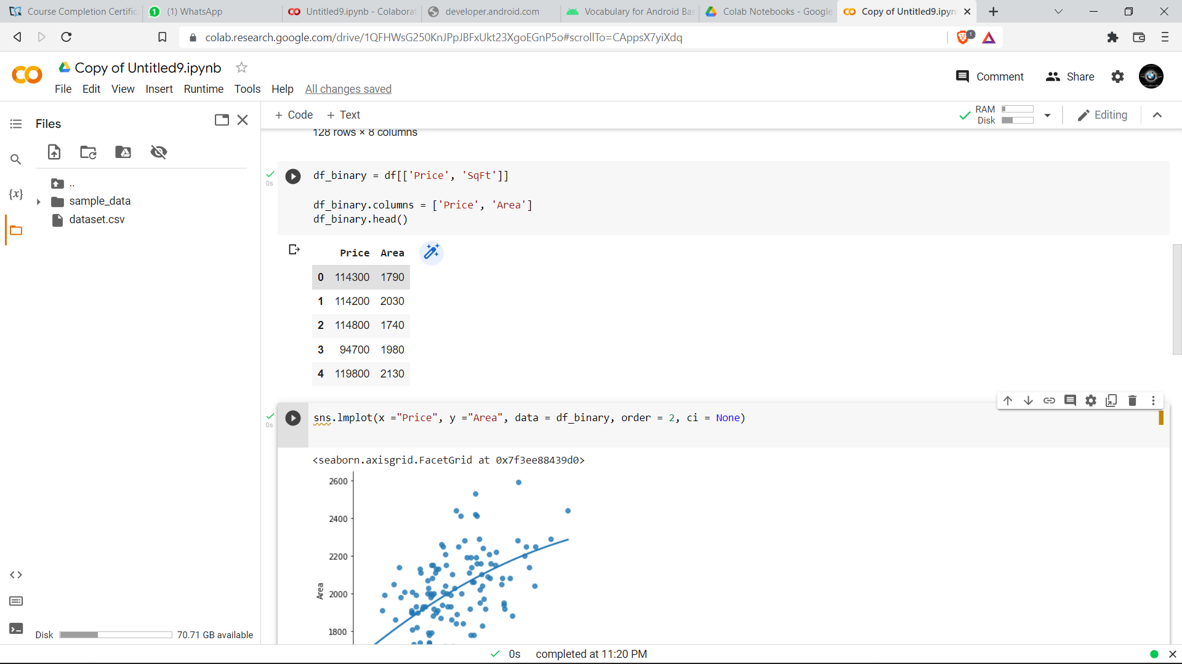

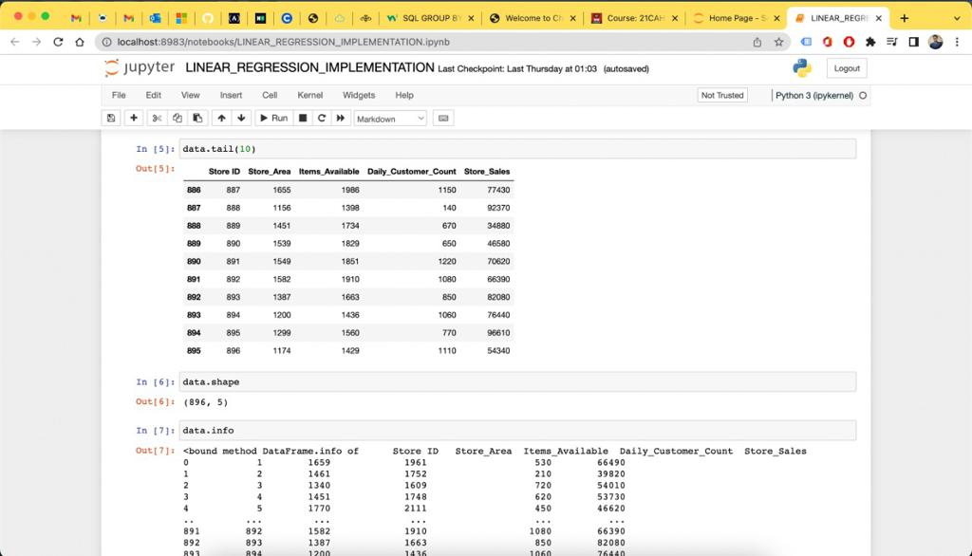

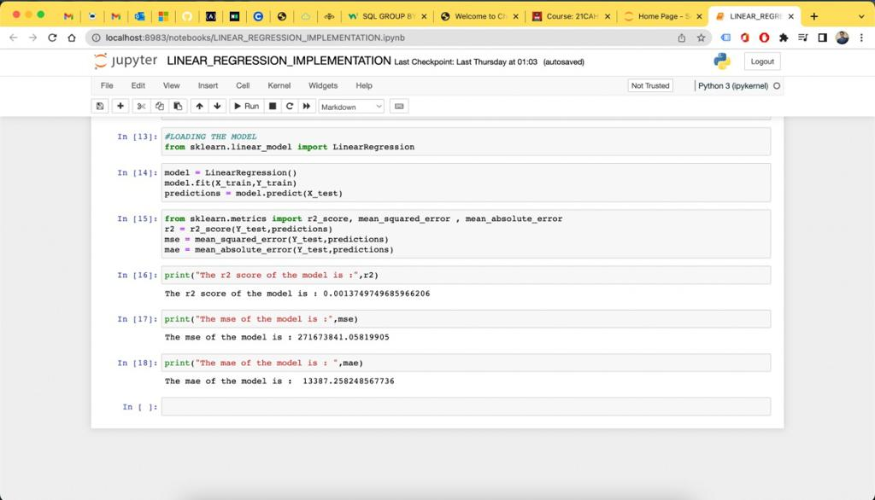

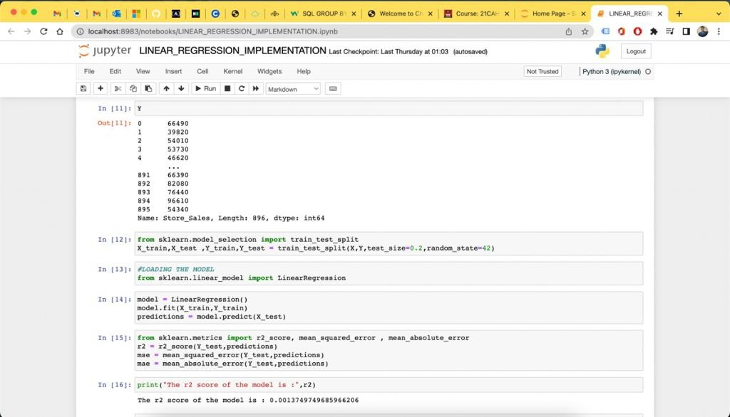

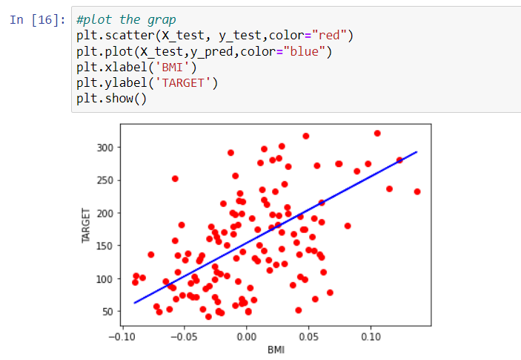

**Learning outcomes (What I have learnt):**

1. I learned about the usage of numpy.
2. I learned the usage of pandas and matplotlib.
3. I learned how to draw graphs in python.